FTP stands for file transfer protocol that is utilized to transfer files, we can also upload or download files from this protocol, for secure transmission that secures the username and password, and encrypts the content, FTP is designed using a client-server model that uses different data and control connections.

In this guide, we will describe the steps to install, configure and secure a FTP server (VSFTPD stands for “Very Secure FTP Daemon“) in CentOS 7.
Note that all the commands in this guide will be run as root, in case you are not operating the server with the root account, use the sudo command to gain root privileges.

Steps:
1) Installing ftp from yum repository
2) Configure ftp by using configuration file vsftpd.conf
3) Creating new users
4) Start and enable the service
5) Testing

Step 1: Installing FTP Server
1. Installing vsftpd server is straight forward, just run the following command in the terminal.

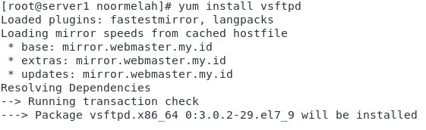
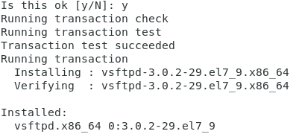

2. Next, in order to allow access to FTP services from external systems, we have to open port 21, where the FTP daemons are listening as follows:
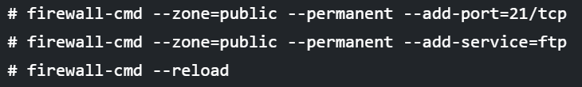

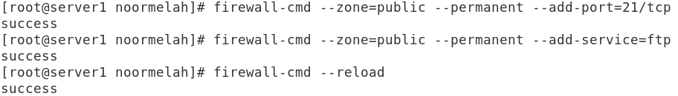

Step 2: Configuring FTP Server
3. Now we will move over to perform a few configurations to setup and secure our FTP server, let us start by making a backup of the original config file /etc/vsftpd/vsftpd.conf:

Next, open the config file above and set the following options with these corresponding values:

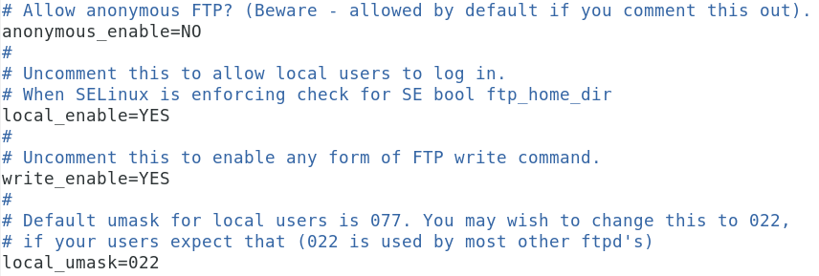

Step 3: Creating new user
4. Now add user1

5. Set the password for user1
Password: vsftpduser1
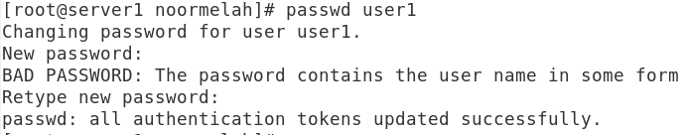

Step 4: Start and enable the service
6. Start the vsftpd service

7. Make it enable service

8. Move in the home directory.
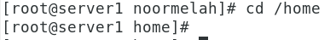

9. List the files.
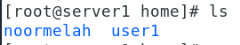

10. Change directory to user1
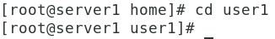

11. Now make the ftp data folder
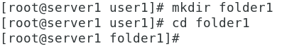

12. Now create the file inside the folder1

13. Now verify
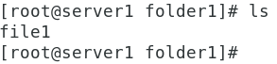

Step 5: Testing
14. Issue ifconfig to get the IP address
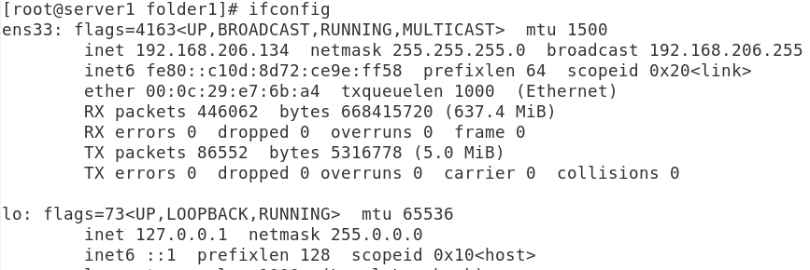

15. Now open your ftp with the server IP address in the format as shown
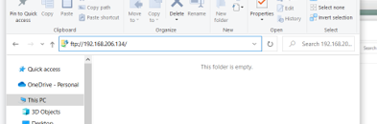

16. Now provide user name and password

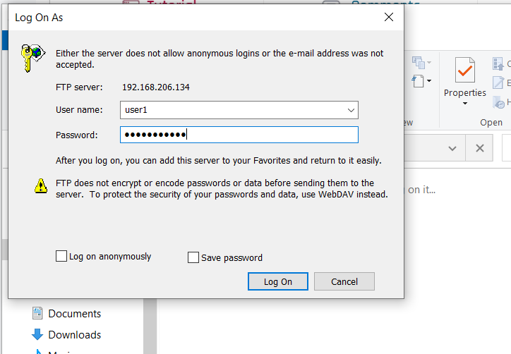

16. Folder1 will be shown. Click the folder1.
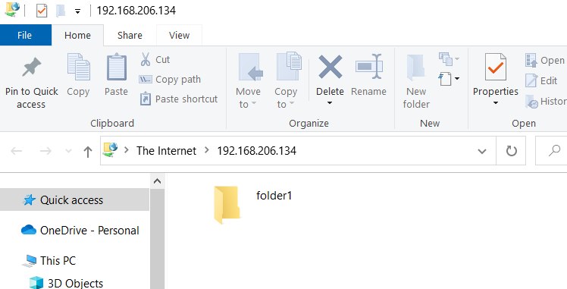

16. File1 will be shown.

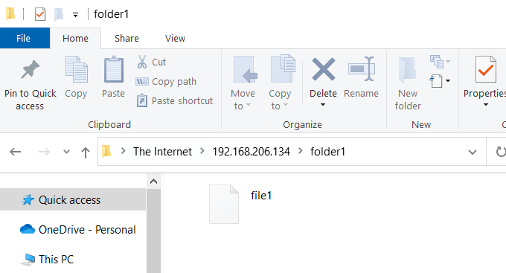

Reference:

https://www.linuxhelp.com/how-to-install-and-configure-ftp-server-on-centos-7#!#google_vignette

